Author proof of expertise. Bibliography and in-text citations. University association so it as an academic material.
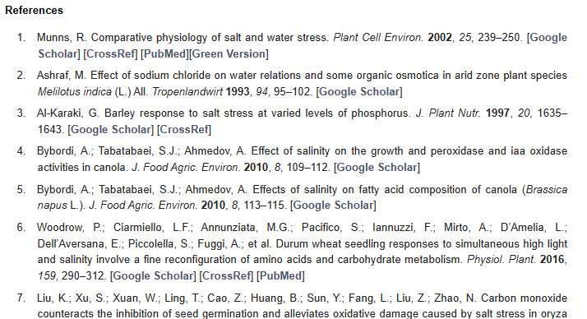
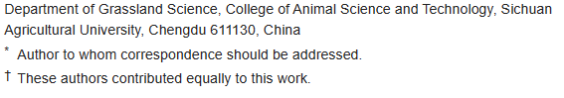
Contributions show authors helped edit and article is supported by a government foundation. 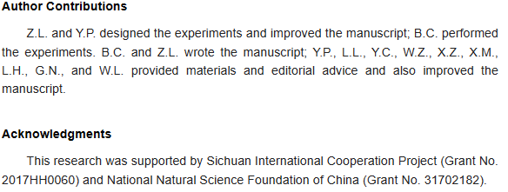
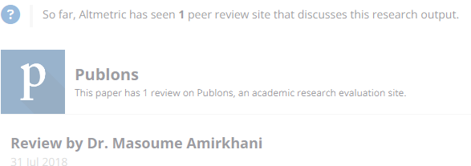
Results and methods sections shown in article.
