**Blog Post One** (Observations)

The selected area for this study is the compound of Prince Rupert Regional Hospital. The address of this area is 1305 Summit Ave, Prince Rupert, BC V8J 2A6, Canada, and the coordinates are 54.3045° N and 130.3315° W. The area has a sloppy terrain, and it has a dry interior grassland covered by Garry oak and black spruce muskeg. Towards the coastal line, the area has a wet coastal forest with cypress trees as the major trees in the region. The region is rich in the diversity of birds, which can be heard on a visit to the coastal section. During the day of the visit to the site, the weather was cold, and it was in the evening. The temperature was about 15° Celsius. This area was selected because of its interesting vegetation that has been adapted to survive along the coast and in a sloppy environment. The following research questions that will help guide the research;

1. What are the invasive plant species in Summit Ave in Prince Rupert?
2. What adaptations has the vegetation in Summit Ave in Prince Rupert undergone to allow the survival of the vegetation in the coastal and sloppy area
3. What is the ecological role of the vegetation to the ecosystem on Summit Ave in Prince Rupert?

Images

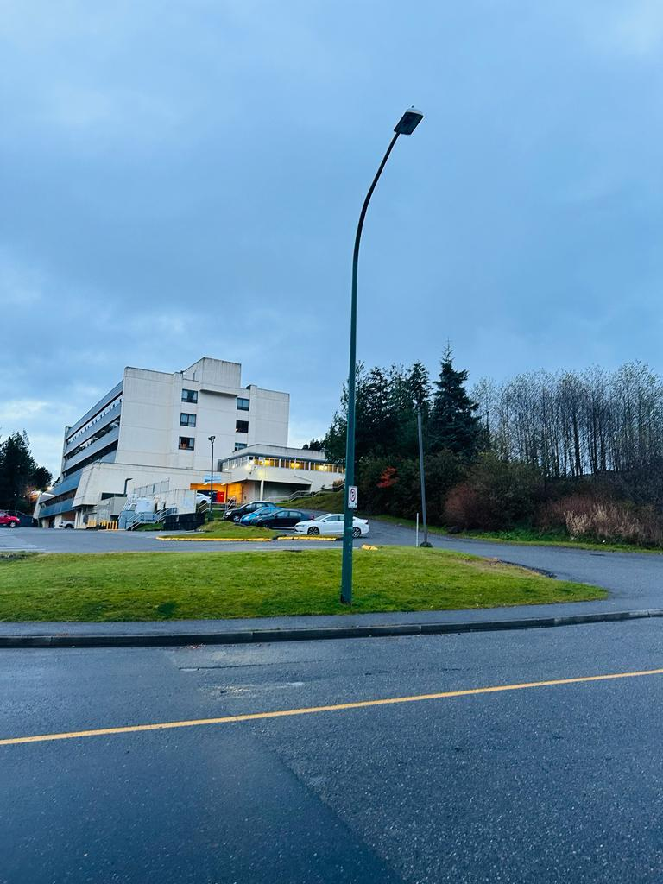

Figure 1 The first site

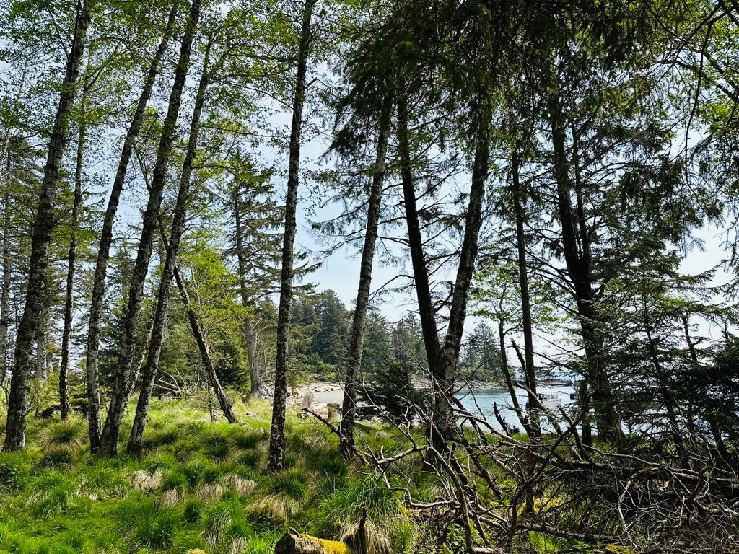

Figure 2 The second site

**Reference**

Kimmins, J. P. (2004). Forest ecology. *Fishes and forestry: Worldwide watershed interactions and management*, 17-43. DOI:10.1002/9780470995242